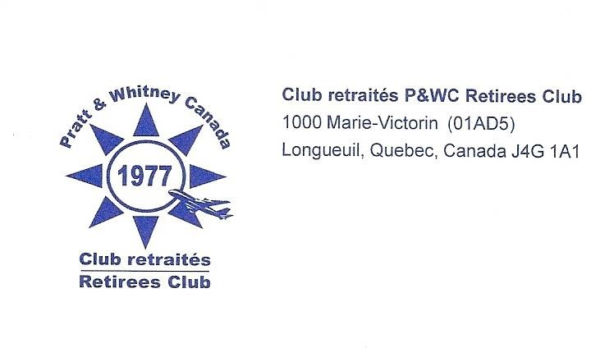
Longueuil

BECOME MEMBERS OF THE P&WC RETIREES CLUB

The Board of Directors of the P&WC Retirees Club is pleased to invite you to our monthly meeting which will be held on the first Wednesday of each month at 10:00 p.m., in La Visitation Hall, located at 1545 Jacques-Cartier blvd. East, Longueuil (currently because of Covid, on Zoom application).
All our members may participate in the following activities:

Line dancing courses – Pétanque – Dinner dance evenings – Golf - Corn Roast - Bowling - Jam sessions - Billiards - Organized trips in Canada and the United States.

For further information, please consult the Recreation Club web site (http://www.clubpwc.ca) under the Retirees Club tab or on Facebook (Pratt & Whitney Canada – Retirees Club des retraités).

Come and meet with former working friends who are now retired and remain active.

We look forward to seeing you soon.

Michel G. Roy, Président Contact : Lise René de Cotret
mgr13970@videotron.ca liserenee@videotron.ca

If you are interested in joining the Club, you can complete the coupon and send it via email to the contact noted above. Payment details will be sent to you. Payment is by Interac in the amount of $20.00. Your membership card will be sent to you by regular mail and a Club lapel pin will be given to you at the next “in-person” meeting.
Name : Phone
Birthday: Badge:
Address : City :
E-mail : Postal code :
Spouse : Birthday :

